TOGAF® Standard – Architecture Deliverables Phase D
Version 1.0
October 2026
Barangay San Antonio Health Department Enterprise Architecture
Barangay San Antonio Health Center, Pasig City
Document Version History
Version  Number | Version  Date | Revised By | Description | Filename
1.0 | October 22, 2026 | UA&P Solution Architecture team | First issue, based on interviews (October 2–21, 2026) and verification answers (October 22, 2026) | D1 - Architecture Deliverables (Phase D).docx

Contents
1. Architectural Artifacts 4
2. Phase D: Technology Architecture Artifacts 7
2.1 Technology Portfolio Catalog 7
2.2 Technology Standards Catalog 7
2.3 Application/Technology Matrix 7
2.4 Environments and Locations Diagram 8
2.5 Network and Communications Diagram 9
2.6 Technology Gap Analysis 9
A Abbreviations 10
Tracking Information
Project Name | Barangay San Antonio Health Department Enterprise Architecture
Prepared By | Rome Victor Mag-iba Sendin (Group Leader); Samuel Anthonius Badillo; Wilson Halim; Kevin Enrico Ang | Document Version No. | 1.0
Title | Architecture Deliverables – Phase D: Technology Architecture | Document Version Date | October 22, 2026
Reviewed By | Dr. Glynnis Lynn U. Bonilla, Medical Officer IV (Executive Sponsor) | Review Date | October 23, 2026
Distribution List
From | Date | Phone/Email
Rome Victor Mag-iba Sendin, Group Leader, UA&P Solution Architecture | October 22, 2026 | romevictor.sendin@uap.asia / 09456315746

To | Action* | Due Date | Phone//Email
Dr. Glynnis Lynn U. Bonilla, Medical Officer IV | Approve | October 23, 2026 | bsahealthcenter@gmail.com
Hon. Thomas Raymond U. Lising, Punong Barangay | Review | October 23, 2026 | bsahealthcenter@gmail.com
Hon. Rachel Marie S. Rustia-Olarte, Co-Chair, Committee on Health & Nutrition | Review | October 23, 2026 | bsahealthcenter@gmail.com
Mr. Joel Pira, Instructor, Solution Architecture (UA&P) | Review | October 23, 2026 | joel.pira@uap.asia
* Action Types: Approve, Review, Inform, File, Action Required, Attend Meeting, Other (please specify)

Architectural Artifacts
While the Enterprise Metamodel is used to support the structuring of architectural information, most stakeholders do not need or wish to know the detail contained within the Architecture Content Framework in this manner. Therefore, the use of catalogs, matrices, and diagrams is introduced to facilitate the presentation of architectural information so that it may be used for reference and governance purposes more readily.
Catalogs are lists of building blocks of a specific type or related types, matrices are grids that show relationships between two or more entities, and diagrams are graphical renderings of architectural content.
In summary, the result of an Architecture Development Method (ADM) developed architecture consists of a number of defined Architecture Building Blocks populated into architecture catalogs, with relationships specified between those building blocks in architecture matrices, and/or also presented as diagrams, as appropriate to satisfy the stakeholder concerns.
The TOGAF® Standard provides a set of recommended artifacts, summarized as follows:
ADM Phase | Artifact
Preliminary Phase | Principles catalog
Phase A | Stakeholder Map matrix  Value Chain diagram  Solution Concept diagram  Business Model diagram  Business Capability map  Value Stream map
Phase B | Organization/Actor catalog  Driver/Goal/Objective catalog  Role catalog  Business Service/Function catalog  Location catalog  Process/Event/Control/Product catalog  Contract/Measure catalog  Business Capabilities catalog  Value Stream catalog  Value Stream Stages catalog  Business Interaction matrix  Actor/Role matrix  Value Stream/Capability matrix  Strategy/Capability matrix  Capability/Organization matrix  Business Footprint diagram  Business Service/Information diagram  Functional Decomposition diagram  Product Lifecycle diagram  Goal/Objective/Service diagram  Business Use-Case diagram  Organization Decomposition diagram  Process Flow diagram  Event diagram  Business Capability map (updated)  Value Stream map (updated)  Organization map
Phase C: Data Architecture | Data Entity/Data Component catalog  Data Entity/Business Function matrix  Application/Data matrix  Conceptual Data Diagram  Logical Data Diagram  Data Dissemination diagram  Data Security diagram  Data Migration diagram  Data Lifecycle diagram
Phase C: Application Architecture | Application Portfolio catalog  Interface catalog  Application/Organization matrix  Role/Application matrix  Application/Function matrix  Application Interaction matrix  Application Communication diagram  Application and User Location diagram  Application Use-Case diagram  Enterprise Manageability diagram  Process/Application Realization diagram  Software Engineering diagram  Application Migration diagram  Software Distribution diagram
Phase D | Technology Standards catalog  Technology Portfolio catalog  Application/Technology matrix  Environments and Locations diagram  Platform Decomposition diagram  Processing diagram  Networked Computing/Hardware diagram  Network and Communications diagram
Phase E | Project Context diagram  Benefits diagram
Requirements Management | Requirements catalog

Phase D: Technology Architecture Artifacts
All core applications are cloud-hosted by the City, PhilHealth, DOH or NNC; the health center needs working devices and a reliable connection. City-issued equipment is audited by the City about every six months and maintained once a year; barangay equipment is checked by the barangay IT team every three months.

Technology Portfolio Catalog
Item | Qty | Owner | Use | Condition
Laptops | 4 | City | Clinical staff and encoder (EMR, PhilHealth, LMIS) | 10+ years old; slow; replacement requested
Desktop workstations | 2 | Barangay | Shared / front desk | Old
Laptop | 1 | Barangay | Shared | Working
Laptop (BNS) | 1 | Barangay | Barangay Nutrition Scholar | Good
Printers | 4 (2 City, 2 Barangay) | City / Barangay | Encoder; front desk | One from 2025; one faulty
Mobile phone | 1 | Health center | Front desk | Working
Internet line (PLDT) | 1 | Barangay (~₱3,000 a month) | Whole center | About 5 outages a month; slow at peak
Internet line (LGU) | 1 | City | Whole center | Weak or unpaid; not used
Generator | 1 | Barangay | Building | Available
Vaccine refrigerator | 1 | City / DOH | Storage | Temperature checked by custodian
Dental chair; autoclave sterilizer; UV/dry-heat cabinet | 1 each | City (+ donations) | Dental clinic | Good; autoclave meets DOH accreditation
Weighing kit (OPT) | 1 | City / NNC | BNS | Incomplete

Technology Standards Catalog
Area | Standard or rule | Source
Software installation | Center cannot install software; the City approves and runs seminars for new programs | Mr. Reyes
System changes | Minor: City Health Officer; major: City Mayor | Dr. Bonilla
Accounts | Individual EMR accounts; passwords managed by IT | Mr. Reyes
Equipment audit | City about every 6 months; barangay every 3 months; City maintenance yearly | Kapitan; Ms. Abong
Clinical equipment | DOH sterilizer standard for accreditation | Dr. Magpali
Records | Data Privacy Act (RA 10173); DOH 7-year retention | Ms. Abong

Application/Technology Matrix
Application | Hosting | Device | Network
City EMR / dental eMED | Vendor cloud (City) | City laptops | PLDT line or phone hotspot
PhilHealth HCI / YAKAP | PhilHealth cloud | City laptops | Same
LMIS, ITIS, FHSIS | DOH / City cloud | City laptops | Same
e-OPT Plus | NNC | BNS laptop | Same; field use offline
Google Drive, Messenger, Viber, Facebook | Public cloud (personal accounts) | Laptops and personal phones | Same; mobile data

Environments and Locations Diagram
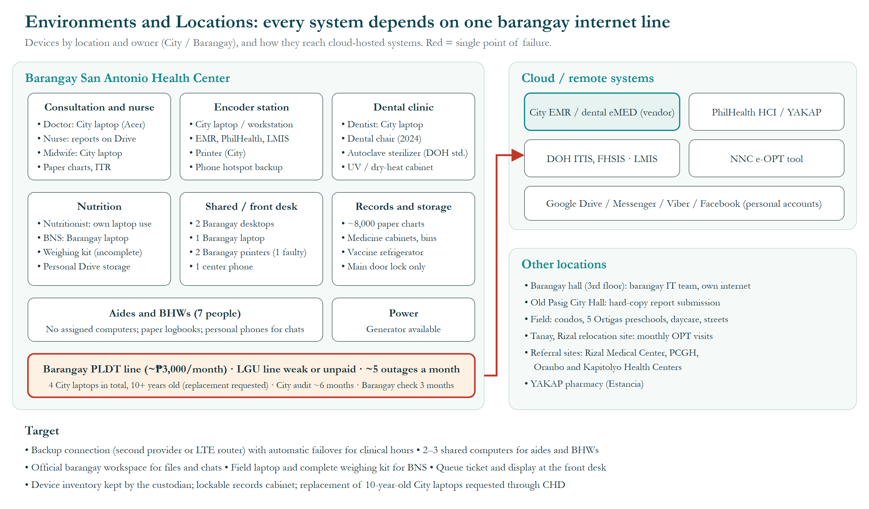
Figure 1. Environments and Locations Diagram.
How to read it: the large box is the health center, divided by area, with each device labelled City or barangay. Cloud systems are on the right; the network line is at the bottom. Red marks the single point of failure.
- Devices: 4 City laptops (doctor, midwife, dentist, encoder), all 10+ years old with replacement requested; barangay-owned: 2 desktops, 1 laptop, the BNS laptop and printers (one faulty).
- Gap: the 4 Pasig Health Aides and 3 BHWs have no assigned computer and use personal phones for work chats.
- Network: every cloud system is reached through one barangay-paid PLDT line (~₱3,000 a month); the LGU line is weak or unpaid; about 5 outages a month, covered by a phone hotspot.
- Physical security: the records room is locked only at the main door; a generator covers power cuts.
- Targets: backup internet (WP7), 2–3 shared computers (WP3), lockable records cabinet (WP4), City laptop replacement (WP8).

Network and Communications Diagram
All traffic from the health center to cloud systems passes through one barangay-paid PLDT line (about ₱3,000 a month); the LGU line is weak or unpaid, and staff use phone hotspots during outages (about 5 a month). The target adds a second provider or LTE router with automatic failover (WP7). See Figure 1.

Technology Gap Analysis
ID | Gap | Target | Controlled by
TG-1 | One PLDT line (~₱3,000 a month); ~5 outages a month; slow at peak | Backup connection with failover | Barangay
TG-2 | 4 City laptops, 10+ years old; replacement requested | Replacement through CHD | City
TG-3 | No computers for 4 aides and 3 BHWs | 2–3 shared computers | Barangay
TG-4 | No official storage or accounts | Barangay workspace with shared storage | Barangay
TG-5 | No queue hardware | Ticket and display at front desk | Health center / Barangay
TG-6 | BNS field data entered later from paper; weighing kit incomplete | Field laptop and complete weighing kit | Barangay
TG-7 | Records room secured only at the main door | Lockable records cabinet; key log | Health center

- Abbreviations
Abbreviations, acronyms and reference codes used in this document and its figures, in alphabetical order.
Abbreviation | Meaning
ADM | Architecture Development Method, the step-by-step method of the TOGAF Standard
BHW | Barangay Health Worker
BNS | Barangay Nutrition Scholar
CHD | City Health Department (Pasig City)
DOH | Department of Health
e-OPT | Electronic Operation Timbang Plus tool of the National Nutrition Council
eMed / eMED | Name of the City's electronic medical record system; “dental eMED” is its separate dental system
EMR | Electronic Medical Record
FHSIS | Field Health Services Information System (DOH)
HCI | Health Care Institution (PhilHealth portal for health facilities)
Hon. | Honorable (title of elected officials)
IT | Information technology
ITIS | Integrated Tuberculosis Information System (DOH)
ITR | Individual Treatment Record (the patient's registration form)
LGU | Local Government Unit
LMIS | Logistics Management Information System
LTE | Long-Term Evolution (4G mobile internet)
NNC | National Nutrition Council
OPT / OPT Plus | Operation Timbang Plus: yearly weighing and measuring of children aged 0–59 months
PCGH | Pasig City General Hospital
PhilHealth | Philippine Health Insurance Corporation
PLDT | PLDT Inc., an internet and telephone provider
RA | Republic Act (a Philippine law)
TG-1 … | Technology gap reference number (Phase D)
TOGAF | The Open Group Architecture Framework (the TOGAF® Standard)
UA&P | University of Asia and the Pacific
UV | Ultraviolet
WP1 … WP9 | Work package (a group of related changes delivered together)
YAKAP | PhilHealth Yaman ng Kalusugan Program (primary-care benefit)

